Guidelines to format one-page abstracts for Eurasian OpenSees 2022
First AUTHOR*ª, Second B. SURNAME^{b}, Another LASTª
ª Affiliation, City, Country (email1@address.edu, email3@address.edu)
^{b} Affiliation, City, Country (email2@address.edu)

Abstract
Abstracts must be written in English and can be produced by simply replacing the contents of this file and saving it as a PDF document (.pdf file format). The final PDF should be renamed following the pattern abstract_surname_name.pdf and submitted through https://eosd2022.weebly.com/submissions by March 31th 2022. Please remember that your submitted .pdf files should not be password protected or otherwise locked.
Your abstract should contain maximum 350 words and may include text along with equations, figures, and references as appropriate. Please use the Times New Roman 11pt font supplied in this template (Style: Normal). If you do include references [1]-[3], be sure to use the IEEE citation style (please read this document).
The title of the paper should be explicit, descriptive and as brief as possible – no more than 20 words in length and in 16pt bold, which should have capital letters only at the beginning of the first word and for proper nouns or acronyms. The names of all authors are in 11pt, while affiliations are in 10pt italic. Note that the corresponding author should be marked with an asterisk. Please also use all caps for the surnames of all authors and precede the surname by the full forename (not just initials). The abstract is preceded by the 12pt bold word “Abstract”, while the text is 11pt fully justified.
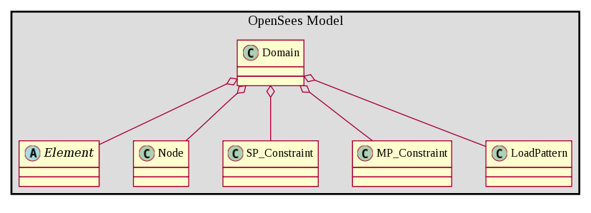
Figure 1 Example of figure
Authors are also invited to submit a full-length paper by September 15th 2022. Submission of the paper is not mandatory, accepted papers will be Scopus indexed.
Keywords: Include a list in 10pt Times New Roman [Style: Keywords] of fewer than ten keywords or terms, separated by commas, using nouns or adjective(s)-plus-noun forms that are relatively standard in the field of spatial structures. The keywords will be used by the scientific committee to manage and classify all the papers. (For example: new material implementation, post-processor, geotechnical application, earthquake engineering application, etc.)

References
- F. McKenna, “Object oriented finite element analysis: Frameworks for analysis algorithms and parallel computing”. Ph.D. dissertation, University of California, Berkeley, 1997.
- F. McKenna, M.H. Scott, and G.L. Fenves, “Nonlinear finite-element analysis software architecture using object composition.” Journal of Computing in Civil Engineering, vol. 24, no.1, pp. 95-107, 2010.
- S. Mazzoni, F. McKenna, M.H. Scott, G.L. Fenves, et al., "OpenSees command language manual." Pacific Earthquake Engineering Research (PEER) Center vol. 264,pp. 137-158, 2006.
- F. McKenna, G.L. Fenves, M.H. Scott, “Open system for earthquake engineering simulation”. University of California Berkley, 2000.

